**Project Report On**



PET SHOP

MANAGEMENT SYSTEM

Submitted in partial fulfillment for the award of

**Diploma in Advance Computing(E-DAC) from C-DAC, ACTS (Hyderabad)**

**Guided by:**

**Mr. Sandeep Kumar**

# Presented by:

**PRN : 220350320057 Mr. Konda Vinay Omprakash**

**PRN : 220350320061 Mr. Kute Sopan Digambar**

**PRN : 220350320062 Mr. Lakkas Aakash Sanjay**

**PRN : 220350320065 Ms. Madhyama Nagpure**

**PRN : 220350320067 Mr. Manish Dixit**

**Centre for Development of Advanced Computing (C-DAC), Hyderabad.**



**ACKNOWLEDGEMENT**

This project “**PET SHOP MANAGEMENT SYSTEM**” was a great learning experience for us and we are submitting this work to Advanced Computing Training School (CDAC ACTS).

We are very glad to mention the name of *Mr. Sandeep Kumar* for his valuable guidance to work on this project. His guidance and support helped me to overcome various obstacles and intricacies during the course of project work.

We are highly grateful to Mr. Mahendra Raju D. (Manager (ACTS training Centre), C-DAC, for his guidance and support whenever necessary while doing this course Diploma in *Advanced Computing (E-DAC)* through C-DAC ACTS, Hyderabad.

Our heartfelt thanks goes to *Mr. Sharan* (Course Coordinator, E-*DAC*) who gave all the required support and kind coordination to provide all the necessities and extra hours to complete the project and throughout the course up to the last day here in C-DAC ACTS, Hyderabad.

# 

# From:

Mr. Konda Vinay Omprakash (220350320057)

Mr. Kute Sopan Digambar (220350320061)

Mr. Lakkas Aakash Sanjay (220350320062)

Ms. Madhyama Nagpure (220350320065)

Mr. Manish Dixit (220350320067)

## TABLE OF CONTENTS

1. Introduction of Project
2. Product Overview and Summary
   1. Purpose
   2. Scope
   3. Overview
   4. Feasibility Study
3. Overall Description
   1. Product Feature
   2. Technology Used
   3. User Classes

3.3 General Constraints

1. Requirement
   1. Functional Requirements
   2. User Interface Requirements
2. Design
   1. High Level Design
   2. Database Design
3. Interface (UI)
4. Test Report
5. Project Management Methodology
6. Conclusion and Future Scope

## Introduction of Project:

We have created an e-Commerce website where the user can buy different types of breeds of dogs, cats and birds.

The platform displays and provides various numbers of breed of dogs, cats and birds to buy for end users. In this modern world everything can be controlled and accessed without the presence of a particular person- that which the time constraint of the modern world demands. This concept is implemented in a complete way through the Pet Management.

It is not practical in today’s life to spend much time only being dedicated for a particular work.

Pet shop management system (PSMS) will handle the animal’s record, pet shop management e- commerce web application. The users can view various pets up for sale and can add to cart and checkout. Admin can manage the orders and the pets. it has many functionalities such as admin panel for management of pets and categories and orders and cart functionalities. Customer which will buy or purchase pets. Shop/vendor which will he can register their shop name at website and take the orders from customers.

## Product Overview and Summary

* 1. **Purpose:**

We need an e-Commerce website where user can buy different types of breed of dogs, cats and birds. There are very few websites which sell pets so that’s why we have created this website so that customers can get more platforms to purchase the pets on online. We are providing various varieties of pets to the customer and also providing user friendly UI to the customer which will help in maintaining the relationship of customer with the company.

## Scope:

E-PET SHOP is a platform where customer can explore the varieties of pets and can buy any of them according to their choices.

## Overview:

Section 3.0, the Overall Description, provides an overview of the components and the relationship between them. Section 4.0 provides the Specific Requirements of the product. In the subsection (4.1) and (4.2) of which the various functional requirements and various interface respectively are discussed. Section 5.0 describes Database Design details.

## Feasibility Study

Feasibility is determination of whether a projects worth doing or not. Before actually recommending the new system it is important to investigate if it is feasible to develop the new system.

Before developing and implementing a system we have sure that our system is feasible in the following ways:

## Technical Feasibility.

1. **Operational Feasibility.**

## Technical Feasibility:

In the type of feasibility study, the system analyst has to check whether it is possible or not to develop the requested system with availability of manpower, software, hardware, etc. The system which we run on windows platform and hence are suitable for the end- user. The system is technically feasible because it does not require too many resources and runs with the browser. A proof of concept was implemented to verify the technical feasibility.

## Operational Feasibility:

In this type of feasibility study, the operation implementation of the system is considered. Checking is done regarding whether it is feasible for the users to use the application. Thus the proposed system is said to be operationally feasible only of the end users are able to understand the system clearly and correctly and can use the system with ease and with the minimum training.

## Overall Description:

* 1. **Product Features**

The project's aim is to provide an e-Commerce website for pets which is containing java (platform independent), JavaScript, bootstrap, JSP and servlet based for user.

## Technology Use

## BACK END :

## JSP and Servlet

MYSQL used for storage of data (Database)

**FRONTEND :**

HTML5

CSS3

Java-Script

Bootstrap

**Platform:**

Web Development:

J2EE Eclipse, Servlet and JSP, MySQL

J2EE Eclipse

In the context of computing, Eclipse is an integrated development environment (IDE) for developing applications using the Java programming language and other programming languages such as C/C++, Python, PERL, Ruby etc.

The Eclipse platform which provides the foundation for the Eclipse IDE is composed of plug-ins and is designed to be extensible using additional plug-ins. Developed using Java, the Eclipse platform can be used to develop rich client applications, integrated development environments and other tools. Eclipse can be used as an IDE for any programming language for which a plug-in is available

Servlet and JSP

Java Servlet technology and Java Server Pages (JSP pages) are server-side technologies that have dominated the server-side Java technology market; they've become the standard way to develop commercial web applications. Java developers love these technologies for myriad reasons, including: the technologies are fairly easy to learn, and they bring the Write Once, Run Anywhere paradigm to web applications. More importantly, if used effectively by following best practices, servlets and JSP pages help separate presentation from content. Best practices are proven approaches for developing quality, reusable, and easily maintainable servlet- and JSP-based web applications. For instance, embedded Java code (scriptlets) in sections of HTML documents can result in complex applications that are not efficient, and difficult to reuse, enhance, and maintain. Best practices can change all that.

Similar to Common Gateway Interface (CGI) scripts, servlets support a request and response programming model. When a client sends a request to the server, the server sends the request to the servlet. The servlet then constructs a response that the server sends back to the client. Unlike CGI scripts, however, servlets run within the same process as the HTTP server.

When a client request is made, the service method is called and passed a request and response object. The servlet first determines whether the request is a GET or POST operation. It then calls one of the following methods: doGet or doPost. The doGet method is called if the request is GET, and doPost is called if the request is POST. Both doGet and doPost take request ( HttpServletRequest) and response ( HttpServletResponse).

The JSP technology--which abstracts servlets to a higher level--is an open, freely available specification developed by Sun Microsystems as an alternative to Microsoft's Active Server Pages (ASP) technology, and a key component of the Java 2 Enterprise Edition (J2EE) specification. Many of the commercially available application servers (such as BEA WebLogic, IBM WebSphere, Live JRun, Orion, and so on) support JSP technology.

MySQL :

MySQL is an open-source relational database management system (RDBMS).A list of commonly used MySQL queries to create database, use database, create table, insert record, update record, delete record, select record, truncate table and drop table etc. MySQL is a relational database management system based on SQL – Structured Query Language. The application is used for a wide range of purposes, including data warehousing, e-commerce, and logging applications.

The most common use for MySQL, however, is for the purpose of a web database. It can be used to store anything from a single record of information to an entire inventory of available products for an online store. In association with a scripting language such as PHP or Perl (both offered on our hosting accounts) it is possible to create websites which will interact in real- time with a MySQL database to rapidly display categorized and searchable information to a website user.

## User Classes

There is three types of user which can access this website. First one is customer which will buy or purchase pets, second one is ADMIN which will manage the users, products and orders and last one is Shop/vendor which will he can register their shop name at website and take the orders from customers.

## General Constraints

Users should have an email and have a browser

## REQUIREMENTS

* 1. **FUNCTIONAL REQUIREMENTS**

## Complete System:

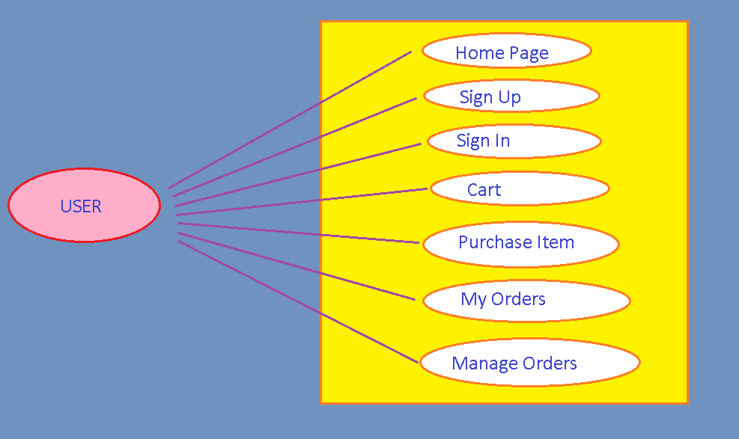**USER**

## 4.1 USER INTERFACE REQUIREMENTS



**Home Page**

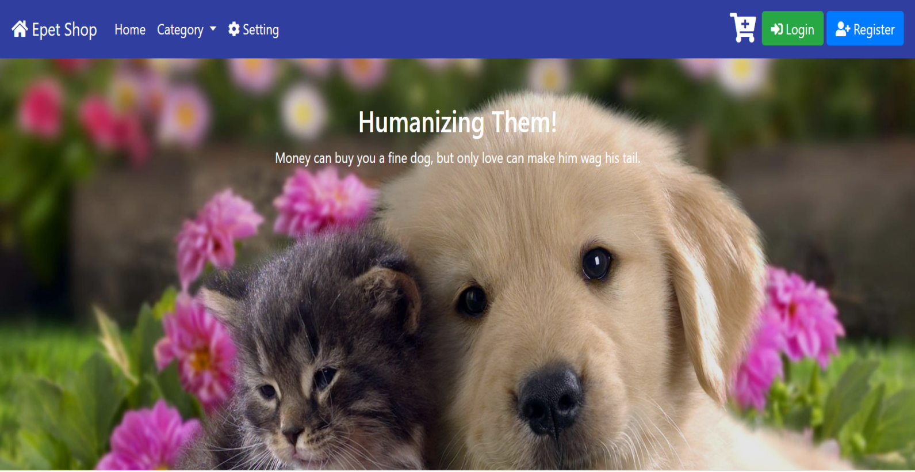



## Product Page:

Dogs-

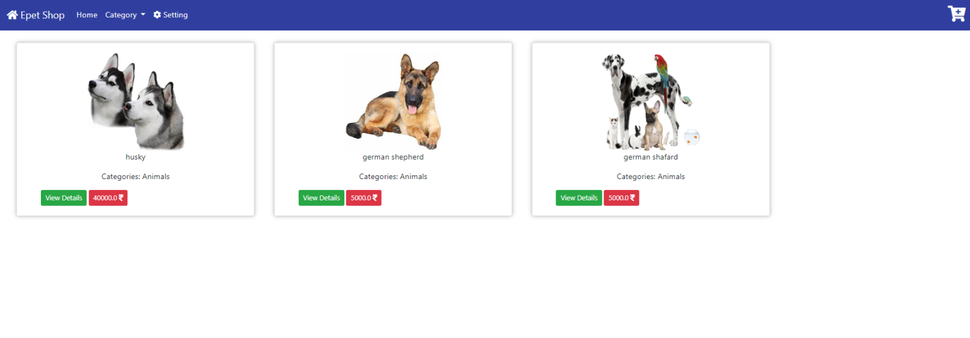

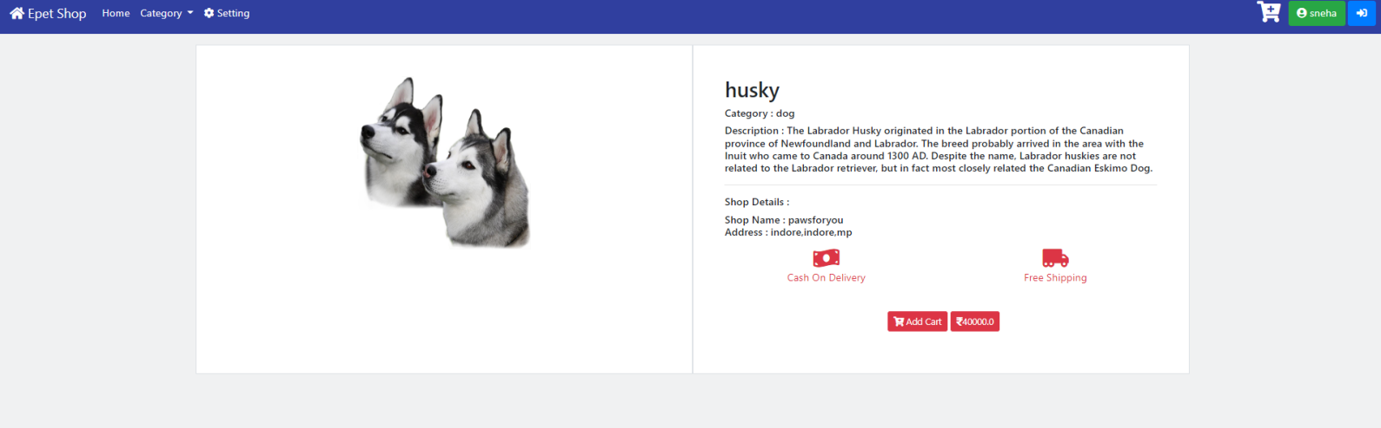

**Cats-**

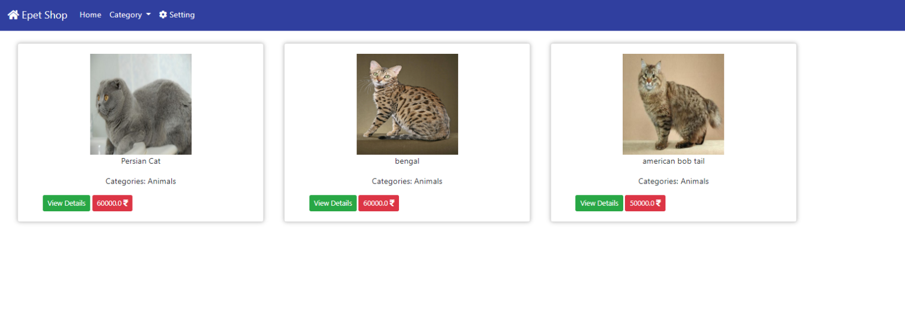

CHECKOUT PAGE-

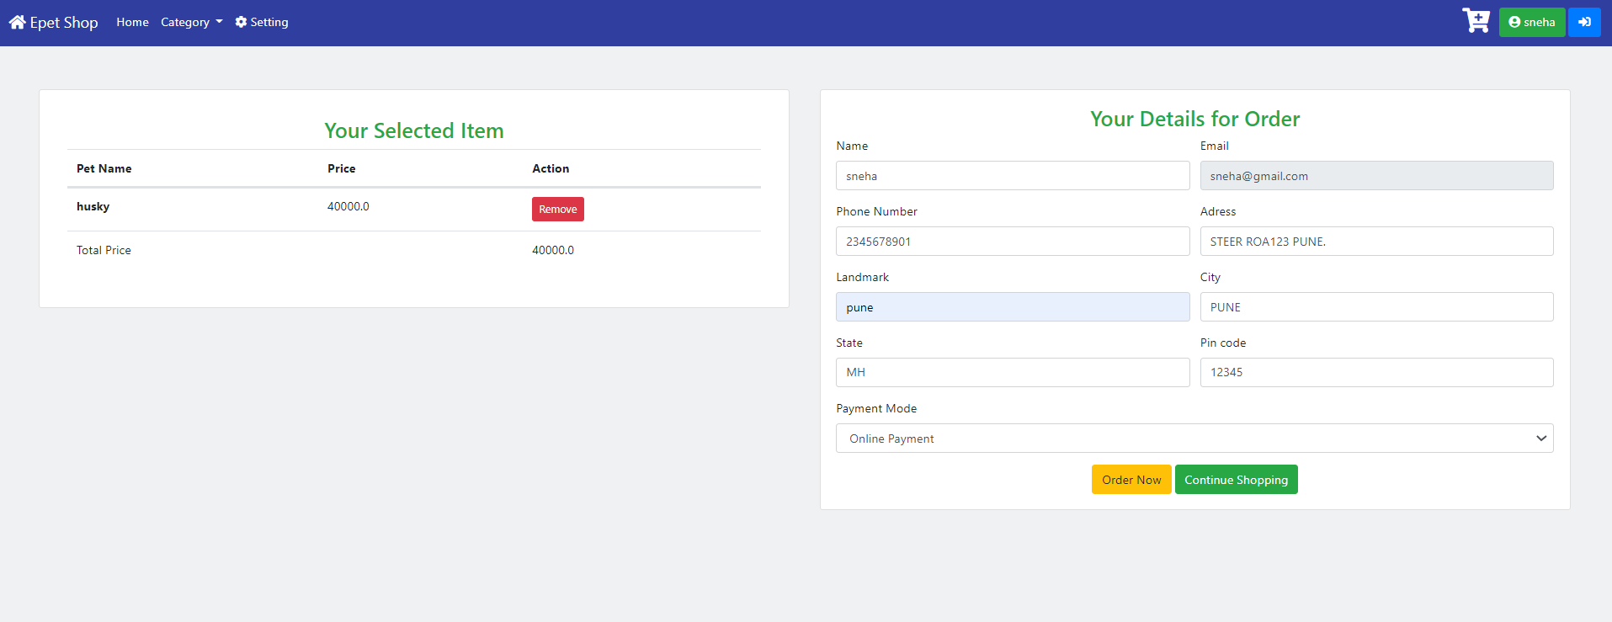

VIEW PETS PAGE-

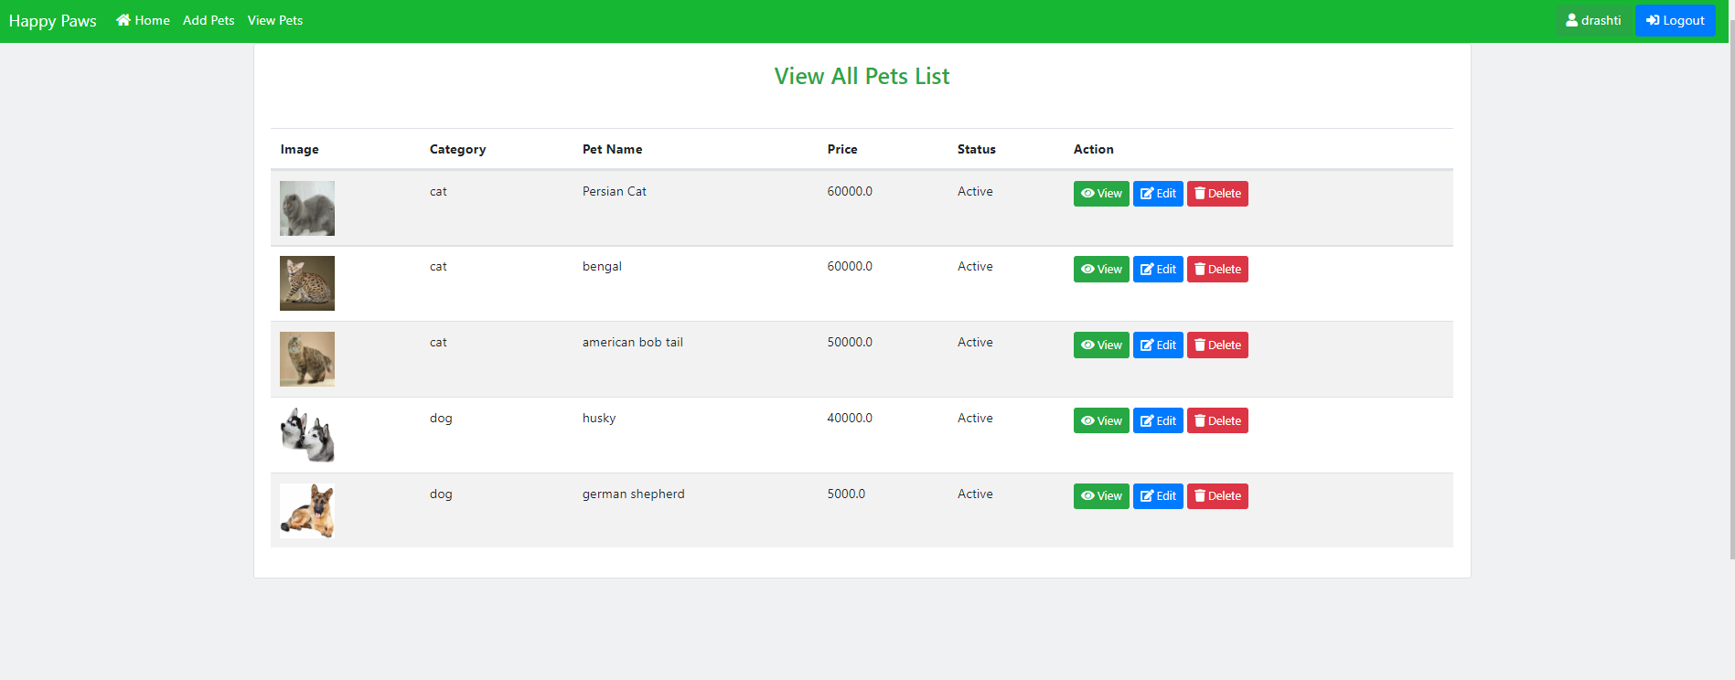

**MY ORDERS PAGE-**

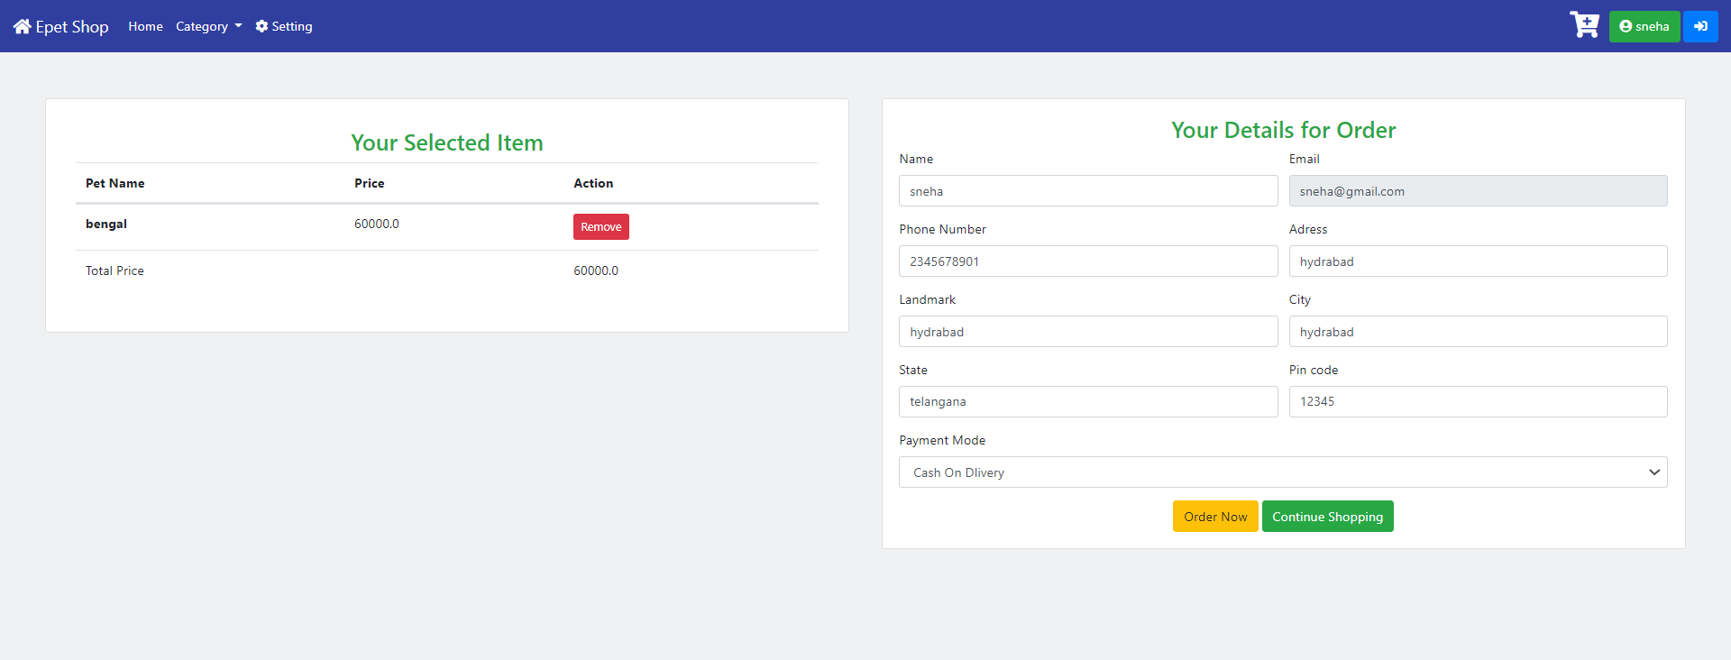

# Categories Page--

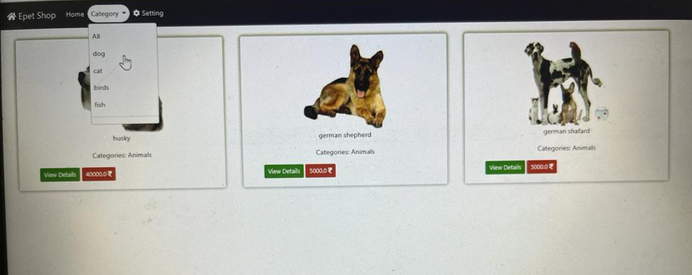

**Shop page-**

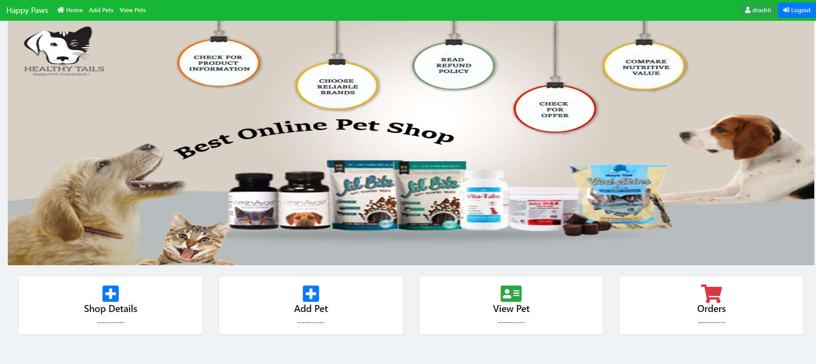

Detail of shop page-

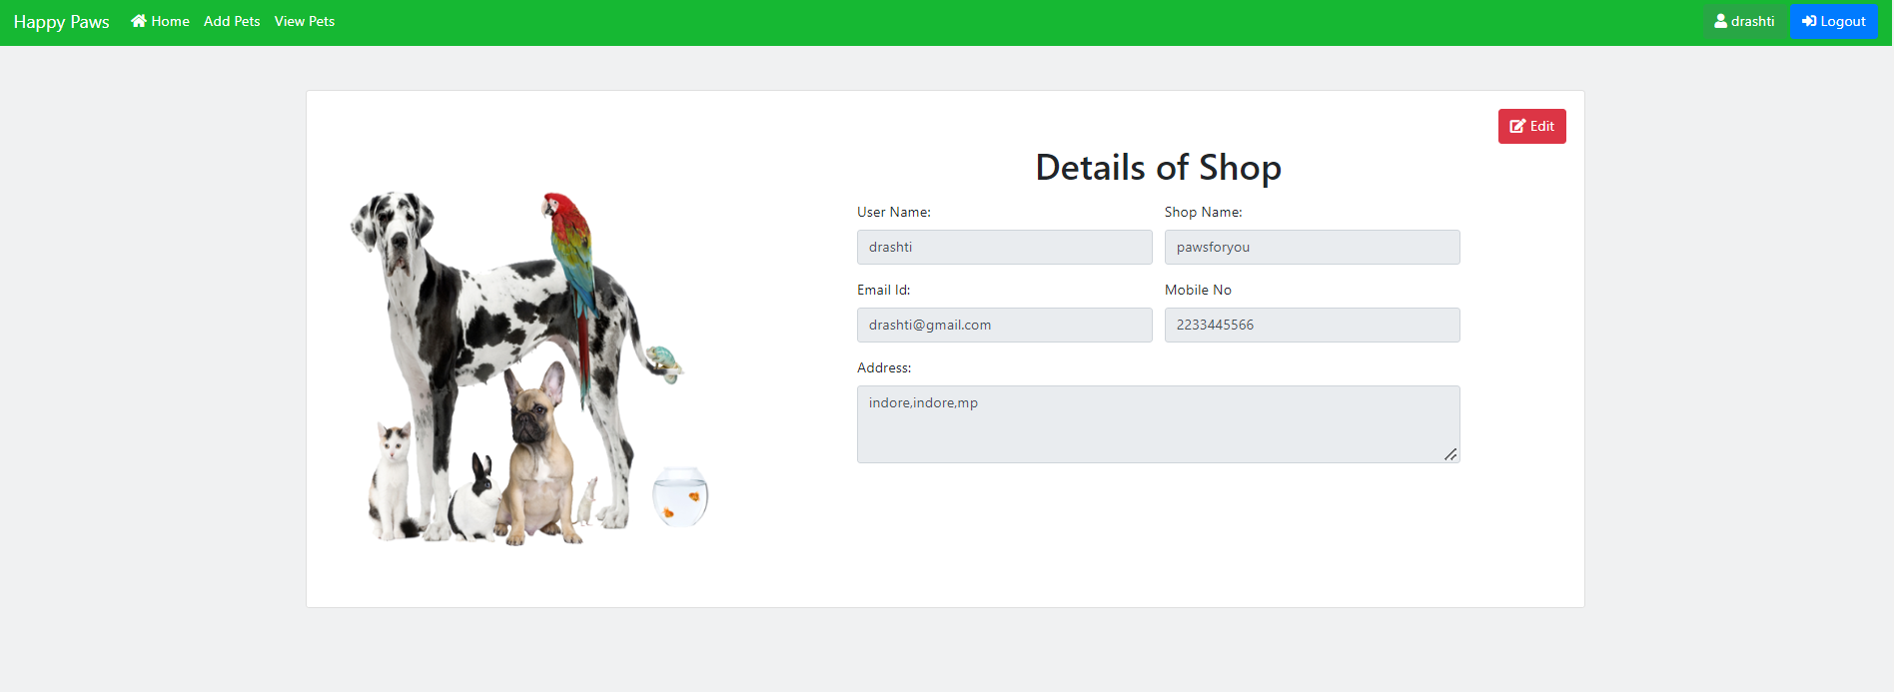

**5.2 Database Design**

The following table structures depict the database design.

## ER Diagram

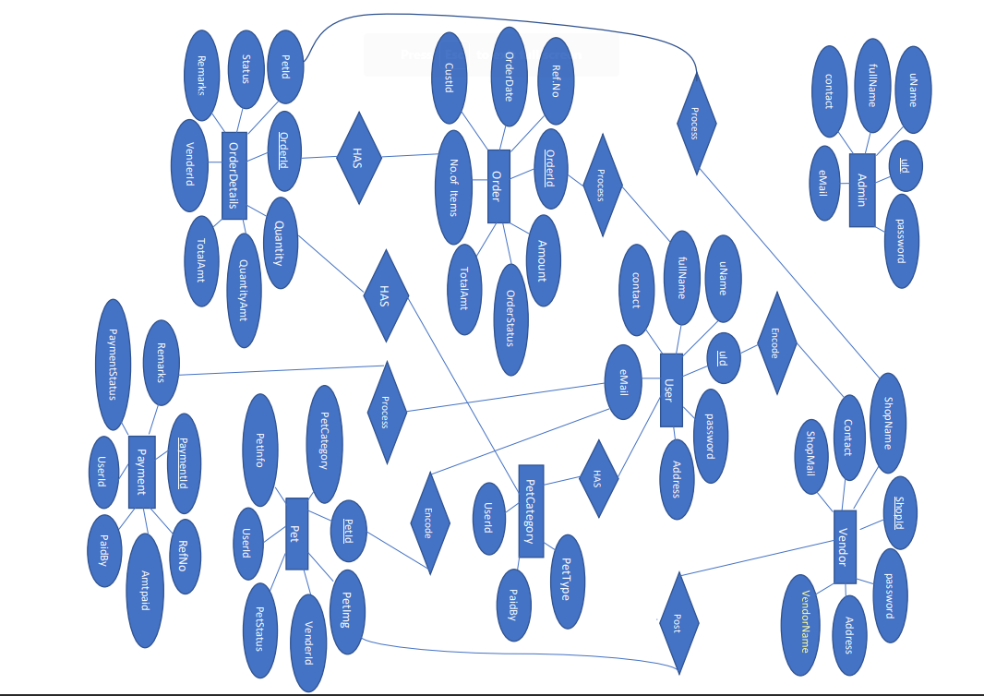

5.SYSTEM DIAGRAMS

# 5.1 DFD

DFD for Admin :

ACTIVITY DIAGRAM FOR ADMINISTRATOR

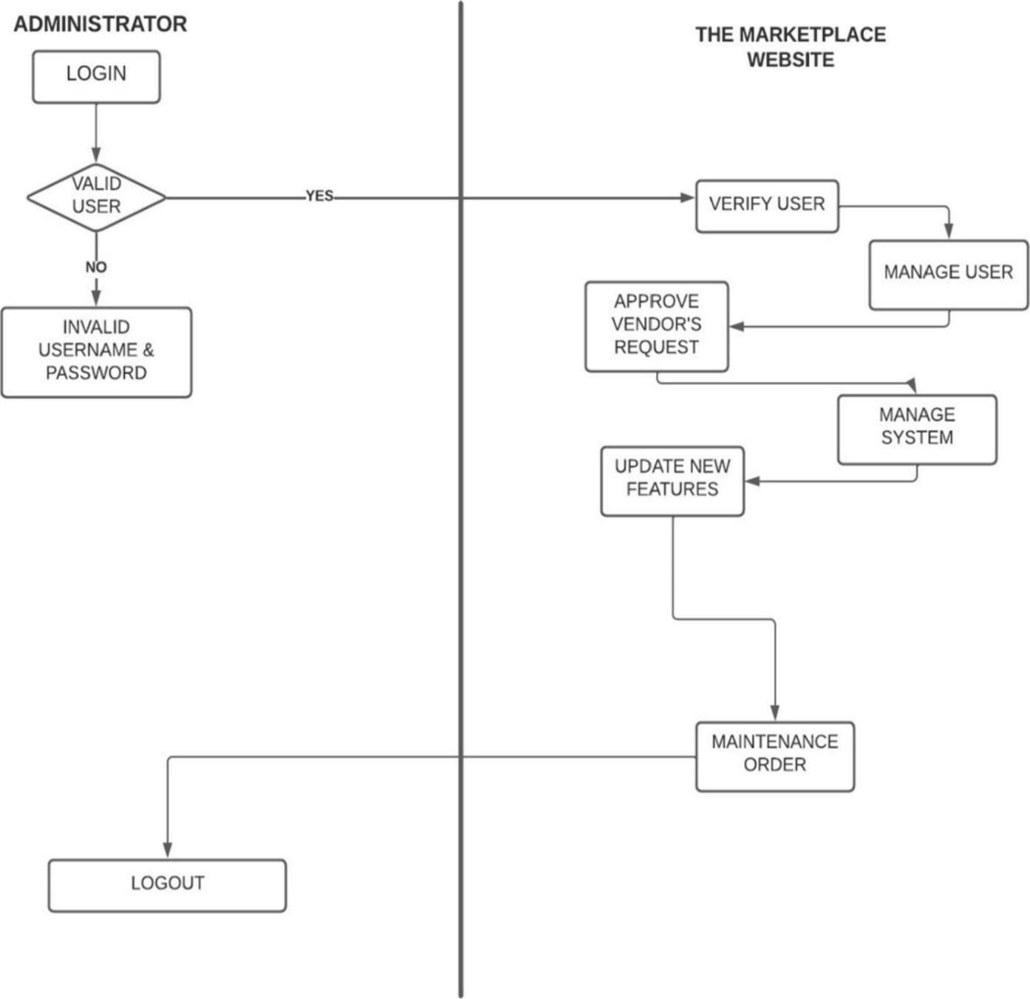

## DFD for Vendor Admin :

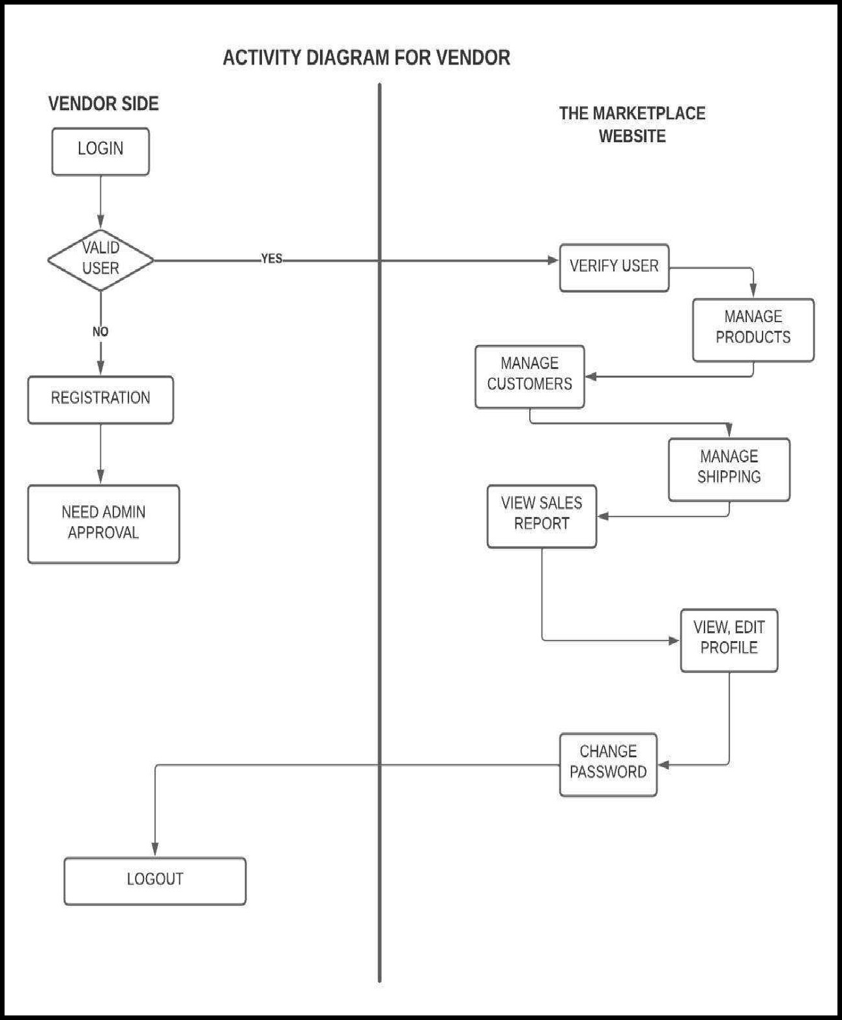

DFD for User/Customer :

ACTIVITY DIAGRAM FOR USER

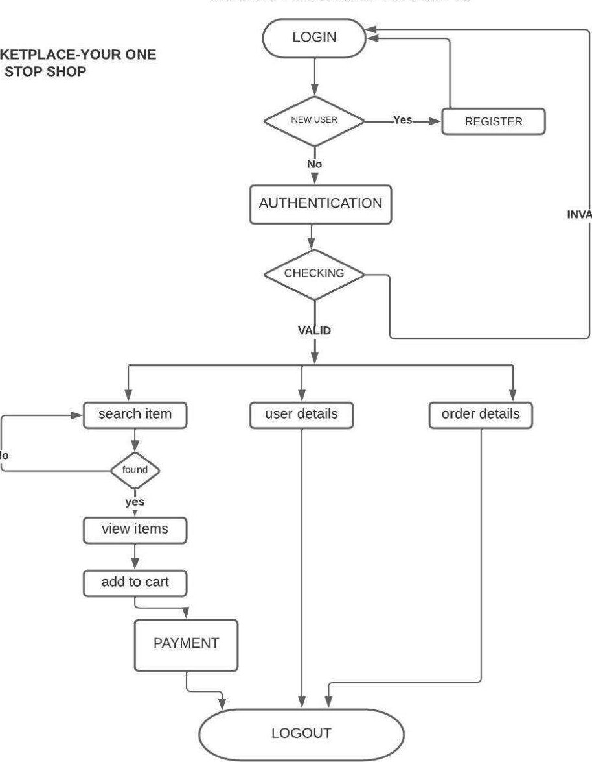

1. **Testing: Test Cases**

## The report of the testing is given here under.

|  |  |  |  |  |  |
| --- | --- | --- | --- | --- | --- |
| **Sr.**  **No** | **Test Case**  **Title** | **Description** | **Expected**  **Outcome** | **Error**  **Message** | **Result** |
| 1 | Login Page | User should see login page when user will enter email and password. | After signing in user to be directed to home page | Invalid Login | Passed |
| 2 | Home page  Displayed | Home page display for every  successful log in. | Home Page  Displayed | No Error | Passed |
| 3 | Categories Page | Users can see different categories of the  pets available. | Category to be selected. | No Error | Passed |
| 4 | My Orders Page | Here, user can see his all its order and can also cancel the order. | User can manage is order. | No Error | Passed |
| 5 | Contact Us | User can contact to the company. | User can write his problem to the company. | No Error | Passed |
| 6 | Checkout Page | User can review its product details. | After clicking on checkout user will place the order. | No Error | Passed |
| 7 | Sign Up | Should not allow any control to be empty if not null | If validated  Allow to go to home page | Validation Error | Passed |
| 8 | Cart | User should be able to see its product details. | All product added to the cart be  seen. | No error | Passed |
| 9 | Sign Out | User should be able to logout from the website | User will logout and will be redirected to the Sign In page. | No Error | Passed |

1. **Project Management Methodology:**

Agile Methodology was used.

**ADVANTAGES OF AGILE MODEL**

* + Very realistic approach to software development
  + Functionality can be developed rapidly and demonstrated
  + Good model for environments that change steadily
  + Increased customer satisfaction
  + Little or no planning required
  + Easy to manage
  + Gives flexibility to developers.

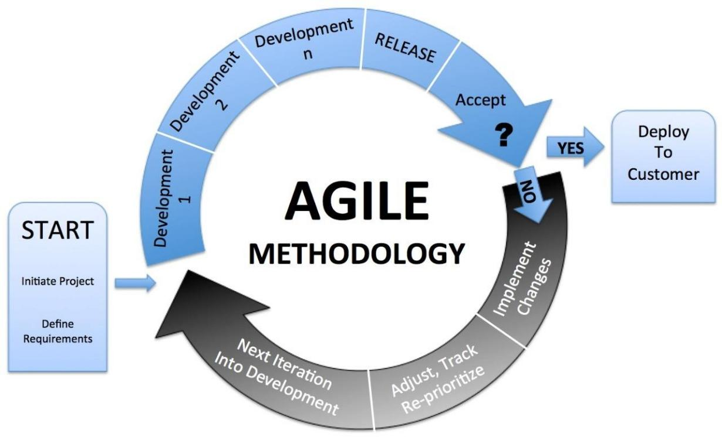

## CONCLUSION AND FUTURE SCOPE

The development of this Pet Shop Management System is great improvement over the manual system which uses lots of manual work and paper. computerization of the system speeds up the process. The Pet Shop Management System is fast, efficient and reliable, Avoids data redundancy and inconsistency. It contains all the functional features described in objective of the project.

The Future scope of this project is to develop a system that can accurately allowing administrator do all the maintenance in the system. Allowing all users to register and use system and designing the basic function to reduce the workload of the users such as scales module, users will feel very easy to work on system. The Software provides accuracy along with a pleasant interface. Make the present manual system more system more interactive, speedy and user friendly.